Lecture 4

**AWS-Cloud watch**

Use budget calculator or budget alarm to avoid payments during free period which is 12 months.

* Instance IDs are important unique
* 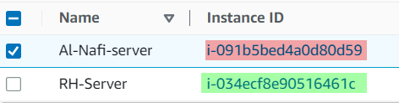
* .
* Monitoring tools in Linux (open source)
* 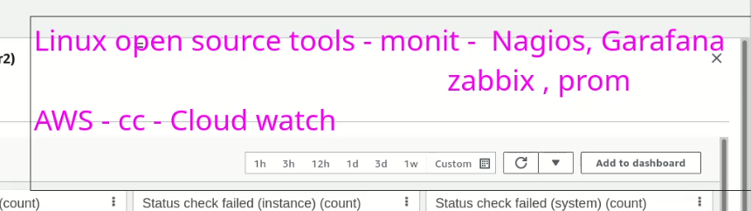
* .
* In AWS it is called CloudWatch
* 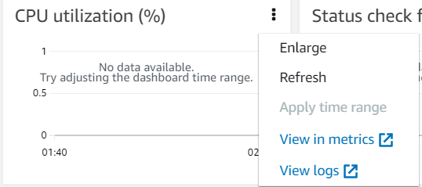
* Graphical user interface, application

  Description automatically generated
* Metrics can be added against each service which is to be monitored.
* GUI comes with few limitations and in this case CLI is best solution, AWS has its own CLI in windows and Linux both environments.
* 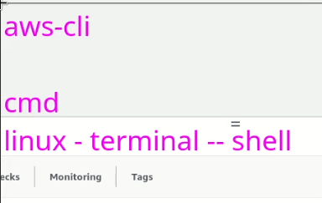
* Username
* 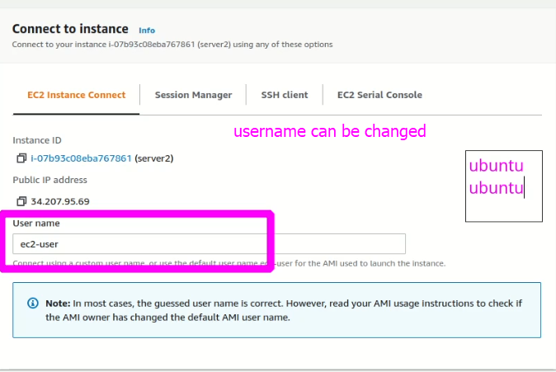
* 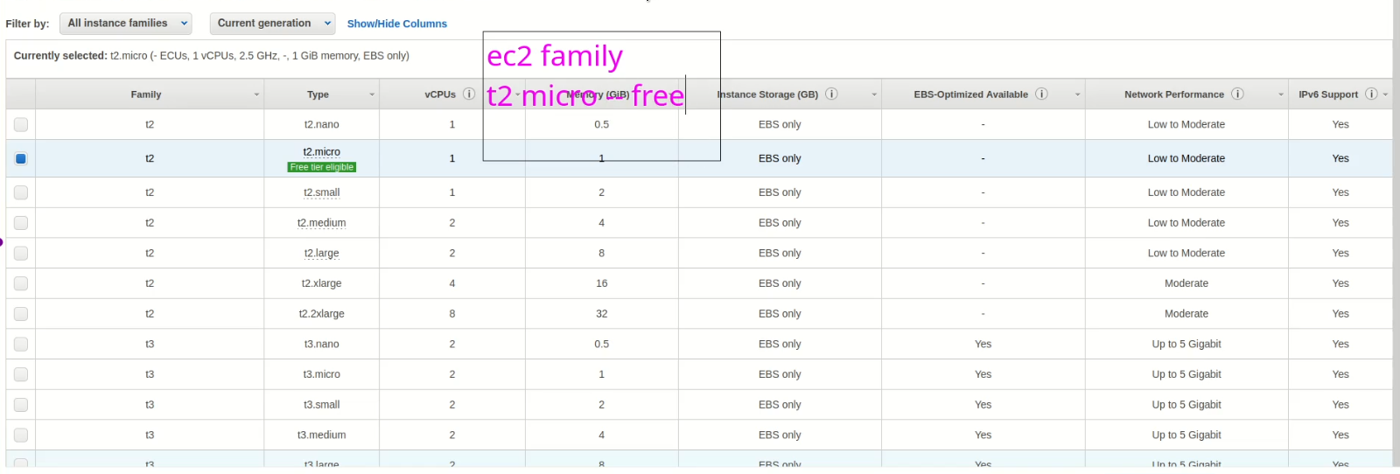
* Amazon is using citrix xen virtualization.
* 